

Madhya Pradesh Electronics Development Corporation (MPSEDC)
State IT Centre, 47-A, Arera Hills, Bhopal, M.P. – 462011,
Phone: +91-755-2518300, Fax: +91-755-2579824
URL: www.mapit.gov.in, Email: info@mapit.gov.in

Parakh – SRS

Document Version History

Version | Date | Author | Comments
1.0 | 26/06/2024 | Dikshant Gitey | Initial draft
1.1 | 26/09/2024 | Dikshant Gitey | Added CMS
1.2 | 31/07/2025 | Tanu jha | Updated SRS

Contents
1. Introduction 4
1.1 Purpose 4
1.2 Scope 5
1.3 Definitions, Acronyms, and Abbreviations 5
1.4 References 6
2. Overall Description 6
2.1 Product Perspective 6
2.2 Product Functions 6
2.3 User Classes and Characteristics 7
2.4 Operating Environment 8
2.5 Design and Implementation Constraints 8
2.6 User Documentation 8
2.7 Assumptions and Dependencies 8
3. Specific Requirements 9
3.1 Functional Requirements 9
3.1.1 Registration and Authentication 9
3.1.2 Role Based Workflow 9
3.1.3 Form Builder and Data Management 9
3.1.4 Asset Management 9
3.1.5 Reporting GIS/MIS/Dashboard 9
3.1.6 Citizen and Agency Request Handling 10
3.1.7 Multilingual and Accessibility 10
3.2 Non-Functional Requirements 10
3.3 Business Rules 11
3.4 External Interface Requirements 12
3.4.1 User Interfaces 12
3.4.2 Hardware Interfaces 12
3.4.3 Software Interfaces 12
3.4.4 Communication Interfaces 13
3.5 System Models and Diagrams 13
3.6 Validation and Verification Requirements 18
4. Project Plan 19
5. Risk Analysis 19
6. Traceability 19
7. Change Management and Process Control 19
8. Appendices 19
8.1 Sample Forms/Workflows 19
8.2 Project Timeline and Go-Live 20
8.3 Traceability Matrix 20
9. Approval 20

Software Requirement Specification (SRS)
Parakh Project – MPSeDC GIS

1. Introduction

1.1 Purpose
This document defines the Software Requirement Specification (SRS) for the Parakh application, a GIS-enabled mobile and web platform developed by MPSeDC. The SRS describes system functionalities, performance requirements, workflows, constraints, and compliance needs to ensure standardization, transparency, and traceability in inspections, surveys, and citizen data collection. This SRS defines the functional, non-functional, process and compliance requirements for the Parakh system—a state-level GIS-enabled solution for digital inspections, surveys, data collection, and citizen service management via web and mobile applications for government departments, agencies, and public users.

1.2 Scope
The Parakh system is designed for:
- Multi-departmental inspections, surveys, and citizen service requests.
- GIS-enabled data capture with photos, videos, and geo-fencing.
- Web and mobile platforms for role-based users (Admin, Nodal Officer, Field Officer, Citizen, Agencies).
- Centralized analytics and reporting dashboards.
- Compliance with Supreme Court mandates and e-Governance guidelines.

1.3 Definitions, Acronyms, and Abbreviations
Term | Definition
GIS | Geographic Information System
MIS | Management Information System
UAT | User Acceptance Testing
OTP | One-Time Password
Dept User | Departmental Employee (Field/Nodal/Reporting Officer)
Agency | External Organization partnering in gov. service
Citizen | General public using G2C forms
Go Live | Official production launch date

1.4 References
1. User Manuals (Mobile & Web)
2. Parakh Data Usage Presentations
3. Parakh Module Status Sheets
4. Mobile APK reference
5. MPSeDC official portals: https://geoportal.mp.gov.in/parakhweb/ and https://gisuat.mp.gov.in/parakhweb/

2. Overall Description

2.1 Product Perspective
Parakh is a government digital governance solution enabling departments to manage inspections and surveys through configurable forms, GIS integration, and analytics dashboards. It interacts with mobile devices (GPS, Camera), departmental databases, and reporting tools.
- Mobile Application: Inspection/survey data entry, GIS location capture, multimedia submission, offline draft and online sync
- Web Portal: Work assignment/monitoring, advanced search/reporting, custom form builder, heat-maps, and dashboardsAbout-Parakh-Features-UsageV2.pptx+1
- Back Office Admin: Form, user, and site/asset management; workflow rule configuration
- Citizen Access: Submission of department-enabled data collection requests

2.2 Product Functions
- User Registration & Authentication
- Role-based Workflow (Admin, Nodal Officer, Field Officer)
- Dynamic Form Management
- GIS Integration & Evidence Capture
- Reporting and Dashboard Analytics
- Asset/Site Management
- Dynamic custom form management (no-code builder)
- Task assignment and progress management (initiated by nodal/admin officers)
- Geo-fenced and geo-tagged inspections
- Multimedia (photo, video, docs) capture for evidence
- Real-time and historical GIS mapping/reporting
- Automated workflow with approval, draft, submit, and history states
- Secure role-based authentication (with OTP for citizens)
- Downloadable, printable, and exportable MIS and compliance reports

2.3 User Classes and Characteristics
- Admin: Manages forms, assets, and users.
- Nodal Officer: Assigns work, verifies inspection data.
- Field Officer: Conducts inspections and submits data.
- Citizen: Submits general-purpose forms.
- Agencies: Submit compliance reports.
User Class | Characteristics/Role
Field Officer | Conduct inspections/surveys, capture evidence, follow assigned tasks
Nodal/Reporting Officer | Assign work, review/approve submissions, monitor dashboard
State Admin | Configure system settings, manage forms and users
Agency User | Submit or coordinate for agency work, compliance, or citizen support
Citizen | Submit requests/applications, view status, receive notifications

2.4 Operating Environment
- Mobile: Android (min version as per APK compatibility)
- Web: Chrome, Firefox, Edge, latest versions, via secure HTTPS
- Server: Cloud/on-premises with scalable capacity for hundreds of concurrent sessions

2.5 Design and Implementation Constraints
- Must comply with SC directives (e.g., Borewell compliance).
- Offline data capture in remote areas with later sync.
- Data security with encryption and role-based access.
- GIS integration with live location capture
- All assignments and evidence must be referenced to unique asset/site IDs
- English and Hindi UI/UX support

2.6 User Documentation
- End-user and admin manuals (web and mobile)
- Context-sensitive help and tooltips
- System training videos and quickstart guides

2.7 Assumptions and Dependencies
- Users have Android devices (version ≥ 8.0).
- Departments provide inspection site datasets.
- Internet connectivity is intermittent; offline sync required.
- Sufficient mobile/wireless coverage for GIS capture
- Timely workflow approval by officers
- All user roles subject to verification and permissions

3. Specific Requirements

3.1 Functional Requirements

3.1.1 Registration and Authentication
Self-registration (Dept, Agency, Citizen); mobile app registration with OTP for citizens; nodal approval workflow for department.

3.1.2 Role Based Workflow
- Nodal Officer assigns survey/inspection work via web to Field Officers; field officer gets assigned task IDs and site coordinates.
- Field Officers must input GIS-tagged survey/inspection details with attachments; forms can be saved as draft and submitted after completion
- Nodal Officer reviews, approves, or rejects submissions

3.1.3 Form Builder and Data Management
- Dynamic no-code interface for creating, editing, and publishing multi-section forms; supports branching, field rules, GIS data, and multimedia attachment
- Form templates for Hostel/School inspections, borewell requests, labor inspection, P&RD, etc.

3.1.4 Asset Management
- Admin creates and maintains list of assets/sites per department (e.g., hostels, schools, agencies, work sites)
- Work assignment ties task to asset/site GIS data

3.1.5 Reporting GIS/MIS/Dashboard
- Dashboards for task status, submitted drafts, approvals, error tracking
- MIS/Heatmap visualization for completed inspections, pending tasks, district/department drill-down.
- Download/export options for .XLS, .PDF, prints

3.1.6 Citizen and Agency Request Handling
- Citizens/agencies get G2C form access, submit requests/readiness/compliance forms (borewell, service requests, complaints)
- Department notified; status visible to citizen post submission

3.1.7 Multilingual and Accessibility
- Bilingual interface (Hindi and English) for mobile/web
- Accessible design compliant to national digital accessibility guidelines

FR-01: Dynamic Form Creation and Assignment
FR-02: Self-registration and Nodal Officer approval
FR-03: Role-based workflow automation
FR-04: GIS tagging and media capture
FR-05: Save draft & submit functionality
FR-06: MIS & Dashboard reporting
FR-07: Asset and Site Management

3.2 Non-Functional Requirements

Category | Requirement
Performance | <3s response for standard form submission and dashboard operations
Availability | ≥99.5% uptime with disaster recovery
Reliability | Audit logs for every data change, workflow audit trails
Security | HTTPS, secure password/OTP, role-based access, periodic security testing
Usability | Contextual guidance, error/help messages
Scalability | Horizontal scaling for peak loads (festival audits, big G2C drives)
Localization | Unicode support for Hindi, form fields, attachments; PDF export support for Indian scripts
Backup & Recovery | Daily incremental and weekly full backups; data retention 7 years
Testability | Full test case coverage for each functional unit (see BRTM)

NFR-01: Performance – <2s response per transaction
NFR-02: Scalability – Support 100K concurrent users
NFR-03: Security – AES-256 encryption, OTP authentication
NFR-04: Usability – Task completion <5 min for first-time user
NFR-05: Availability – 99.9% uptime with DR
NFR-06: Compliance – Adherence to e-Gov & SC mandates

3.3 Business Rules
BR-01: Citizens can only access general-purpose forms.
BR-02: GIS location capture mandatory for inspections.
BR-03: Draft forms must be submitted within SLA timeline.
BR-04: Nodal Officers must verify/reject within 48 hours.
- Each Form ID is unique, must relate to a specific asset/site and task assignment
- Mandatory GIS (lat/long) and date/time for every inspection or survey
- Nodal officer cannot assign new work until previous tasks are closed or justified
- Media attachment (photo/video) required for hostel/school/asset inspection form submission
- Citizens can submit G2C forms anytime, but assignment of work is always by department admin
- Draft forms can be updated any number of times before final submission
- Real-time status and access logs must be available to admin and security audits

3.4 External Interface Requirements
- Mobile App: Android application with offline caching.
- Web Portal: Accessible via secure HTTPS.
- Database: Centralized data storage with role-based access.
- Reporting Interface: GIS dashboards and MIS reports.

3.4.1 User Interfaces
- Mobile app: Home, Task list, Form entry, Attach/upload media, Draft/save, GIS capture UI, Status
- Web app: Dashboards, User/Asset/Form management, Task assign, Approval, MIS, Export, Configuration
- Citizen portal: Form browse, Submit, OTP login, Status check

3.4.2 Hardware Interfaces
- Android phones (minimum API level as per released APK, GPS support)
- Standard office desktops/laptops with modern browsers

3.4.3 Software Interfaces
- Google Maps/Open GIS API for mapping and coordinates
- SMS/OTP API service for citizen login
- Integration-ready data export modules [.XLS, .PDF, .CSV]

3.4.4 Communication Interfaces
- All external communication encrypted (HTTPS, SSL/TLS); mobile sync via secure REST
- Notification (email/sms) for key status changes for officers/citizens

3.5 System Models and Diagrams
- Use Case diagrams: Registration, Work Assignment, Form Submission/Approval, Reporting
- Workflow diagrams: Task lifecycle, Form lifecycle, Approval process
- Data models: User, Asset, Form, Submission, Audit Log
- GIS integration module flow
(Sample outline - include in SRS deliverable as visual assets)
Parakh application’s system models and diagrams can be divided into several core visualizations as required for the SRS deliverable conforming to CMMI Level 5 standards. These diagrams standardize the system logic, workflow, and information relationships. Here’s a complete set of recommended diagrams for the Parakh platform, with examples for each category based on your manuals and functional workflow:

Use Case Diagram
Actors & Major Use Cases
- Actors: Field Officer, Nodal Officer, Admin, Citizen, Agency
- Use Cases: Registration, Login, Assign Task, Fill Inspection Form, Approve/Reject Submission, View Reports/MIS, Upload Media, GIS Location Capture
+------------------+
| Admin |
+-------+----------+
|
Assign Task-------------------------+
| |
+-------v-----------+ +------v-----------+
| Field Officer | | Nodal Officer |
+-------+-----------+ +-----+------------+
| |
Fill Inspection Form Approve/Reject Submission
|
Upload Media, Capture Location
|
+-------v-----------+
| Citizen/Agency|
+------------------+
| Registration, G2C submission |
+------------------+
| View Status, Receive Updates |
+------------------+
[Includes interaction with GIS, form builder, asset assignment]

Workflow Diagram
Inspection Task/Survey Lifecycle
[Admin/Nodal Officer]----->Assign Work----->[Field Officer]
|
v
Fill Form/Draft/Submit
|
v
[Nodal Officer Review]
/ \
Approve Reject
| |
Finalize Data Notify Field Officer (with comments)
|
[Dashboard/MIS]

Data Model Diagram (Entity Relationship)
Main Entities and Relationships
Entities:
- User (Field Officer, Nodal, Admin, Citizen, Agency)
- Asset/Site (Hostel, School, Borewell, etc.)
- Task/Assignment
- Form/Submission
- Attachment (Photo, Document, Video)
- Audit Log
Relationships:
User <----- (assigned by) ----- Nodal Officer
User <----- (fills)----------- Form Submission --- (links to) ---- Asset/Site
Form Submission -- (includes) --> Attachment (Media)
Form Submission -- (logs update) --> Audit Log
Admin -- (manages) --> Asset/Site, Forms, Users

GIS Integration Flow Diagram
Mobile/Web App
|
Capture Site Coordinates
|
Submit Form Data (including GIS info)
|
Server Receives
|
Geo-Tagged Data stored in DB
|
MIS/Dashboard presents Map View:
|
Admin/Nodal Officer reviews GIS-based submissions/heatmaps

Sequence Diagram (Inspection & Approval)
- Admin assigns asset/site for inspection.
- Field Officer receives notification.
- Field Officer opens task, fills form, attaches media, captures GIS data, saves as draft.
- Once completed, Field Officer submits form.
- Nodal Officer reviews, either approves or requests revision.
- Upon approval, entry moves to MIS report/dashboard.

Admin Field Officer System Nodal Officer
| | | |
Assign Task |------------>| |
|<---notify---| |
| | |
Fill Form, Save Draft |
|----submit---->| |
|------validate------>| |
|<-----approve/reject------|
| | |
View Completed Tasks |

Parakh System Models & Diagrams
(as per CMMI Level 5 SRS Standards)
1. Use Case Diagram
The Use Case Diagram shows the interaction of different actors with the Parakh system.
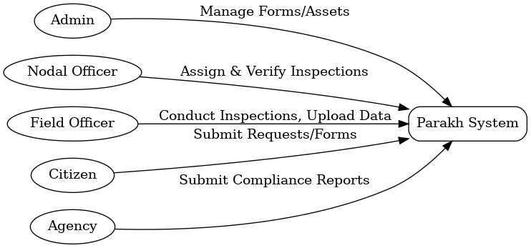
2. Workflow Diagram
The Workflow Diagram illustrates the inspection lifecycle from work assignment to report generation.
3. Entity Relationship Diagram
The ER Diagram depicts entities in the Parakh application and their relationships.
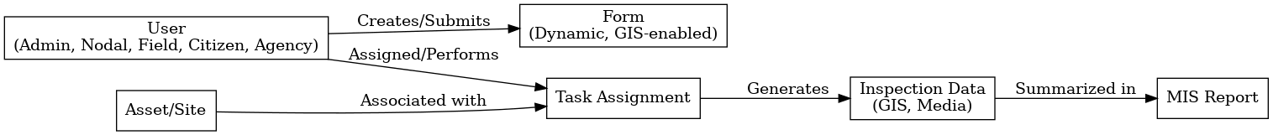
4. GIS Data Flow Diagram
The GIS Data Flow Diagram shows how data flows from mobile capture to dashboards.
5. Sequence Diagram
The Sequence Diagram demonstrates step-by-step interactions between users and the system.
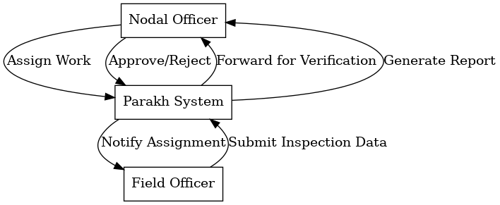
Summary Table
Diagram Type | Main Elements | Purpose/Scope
Use Case Diagram | Actors, Major Use Cases | Functional Overview
Workflow Diagram | Task, Form Fill, Approval, Dashboard | Process Lifecycle
Data Model (ER) | Users, Assets, Forms, Attachments, Logs | Data Relationships
GIS Flow Diagram | Data capture, DB store, map view | Geo-location Handling
Sequence Diagram | Task Assignment, Submission, Approval | Core Transaction Flow

3.6 Validation and Verification Requirements
- Each business and functional requirement traced to one or more:
  - Design module
  - Implementation element
  - Test case in validation/test plan (see BRTM)
- Systematic walkthroughs with stakeholders prior to UAT and Go-Live
- Automated test harness for regression, performance, and security testing
- Full compliance and process audit cycle logs

4. Project Plan
Project phases with estimated vs actual completion as per Parakh Labour Tribal Module status sheet.

5. Risk Analysis
R1: Poor internet → Mitigation: Offline sync.
R2: User adoption resistance → Training, manuals.
R3: Data security risks → Encryption, RBAC.

6. Traceability
Refer Business Requirements Traceability Matrix (BRTM) for requirement-to-design-test mapping.

7. Change Management and Process Control
- All requirements reviewed and versioned using internal review board
- Requirements change requests logged, impact analyzed, and approved per CMMI policy
- Feedback cycles after UAT, Go-Live, periodic audits for continuous improvement

8. Appendices

8.1 Sample Forms/Workflows
- Hostel/Schoool Inspection template
- Borewell Compliance checklist
- Admin dashboard screenshot samples

8.2 Project Timeline and Go-Live
- [Refer attached Parakh-Labour-Tribal-Status.xlsx]Parakh-Labour-Tribal-Status.xlsx

8.3 Traceability Matrix
(To be provided as a separate section in BRTM—see prior responses for template details.)

9. Approval
- Prepared by: ____ (SRS Author/Owner)
- Reviewed by: ____ (Department Heads, QA)
- Approved by: ____ (OIC/Project Director)

